Week beginning 13.7.2020 Day 5
Spellings

Practise these words.

Read | Trace | Practise | Practise | Practise | Practise
arrive | arrive
extreme | extreme
history | history
remember | remember
probably | probably

Now write a sentence for each word. Can you spell it correctly in each sentence without looking at the table?

________________________________________________________________________________________________________________________________________________________________________________________________________________________________________________________________________________________________________________________________________________________________________________________________________________________________________________________________________________________________________________________________________________________________________________________________________________________________________
_____________________________________________________________________________

Maths 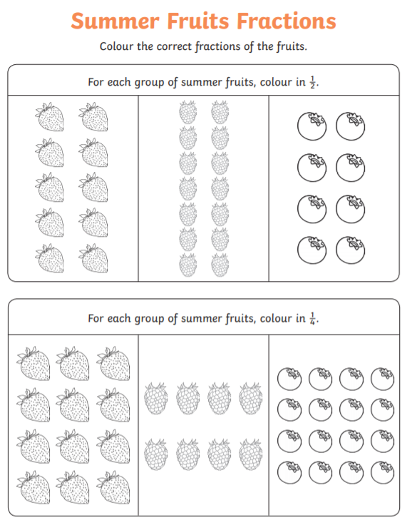

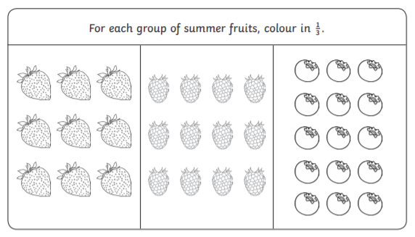
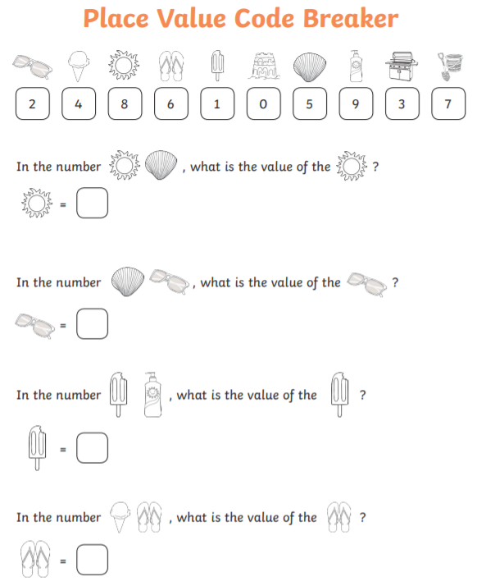

English
