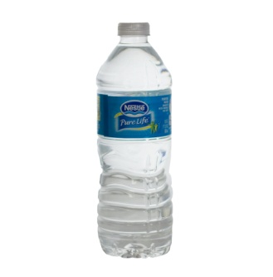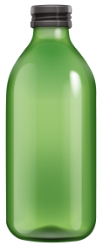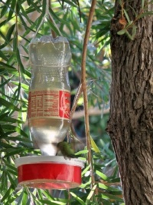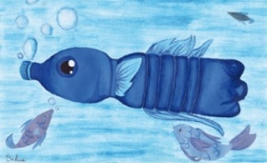
Design and Technology
Recycling Home Challenge
Instead of throwing away an empty plastic bottle, can you make it into something else useful? What could you create? Your challenge is to think careful about reusing a plastic bottle or even more than one! The plastic bottle(s) can be any size, colour or shape.
We would love to see what you choose to create. Please email a photograph of your finished creation to Mrs Eate by Friday 3rd December, ready for judging. Mrs Eate’s email address is geate@mcps.org.uk.
There is no charge for entering the competition and a prize will be awarded to the winning child in each year group. No joint sibling entries please.
***If you are sending a photograph of yourself in the picture as well, please make sure that you have a parent’s/guardian’s permission to be featured on our school website, thank you.
Entries should be marked: Child’s name – year group – class- creation
Have fun and happy creating to you all!
