Week beginning 13.7.2020 Day 4
Spellings

Practise these words.

Read | Trace | Practise | Practise | Practise | Practise
actual | actual
complete | complete
appear | appear
address | address
different | different

Now write a sentence for each word. Can you spell it correctly in each sentence without looking at the table?

________________________________________________________________________________________________________________________________________________________________________________________________________________________________________________________________________________________________________________________________________________________________________________________________________________________________________________________________________________________________________________________________________________________________________________________________________________________________________
_____________________________________________________________________________

Maths
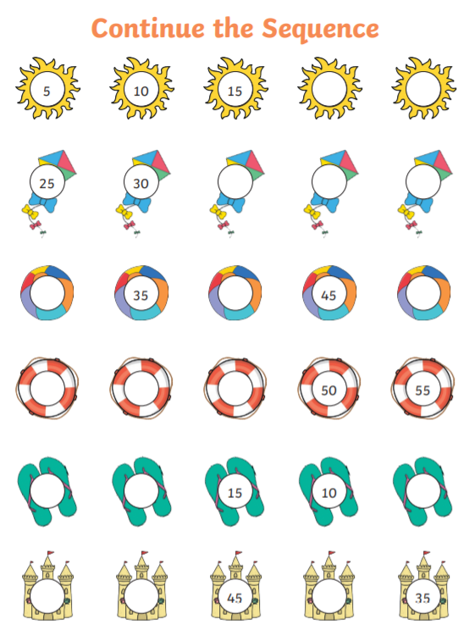

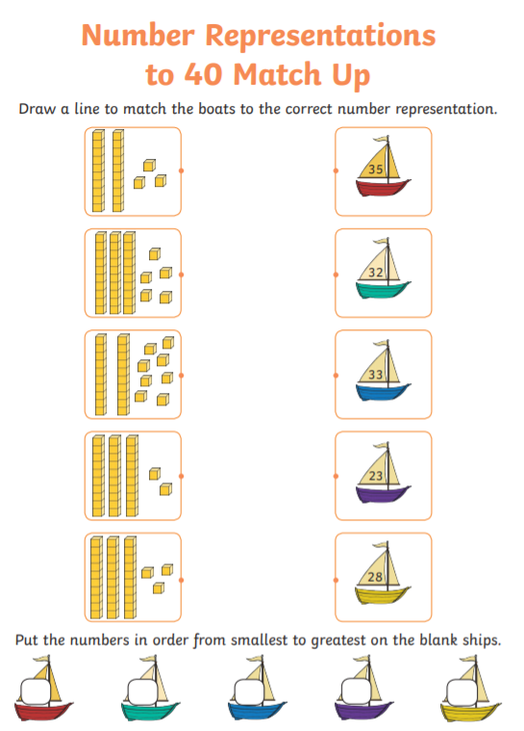

English
