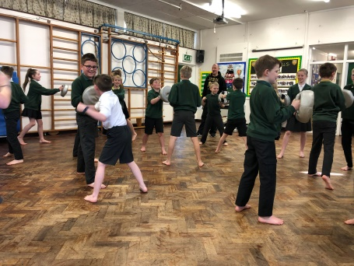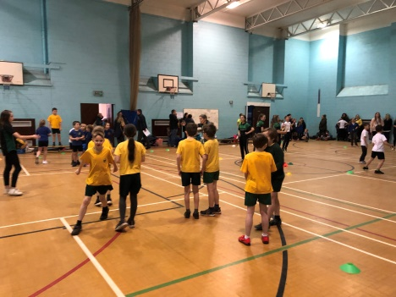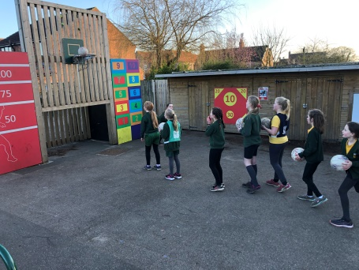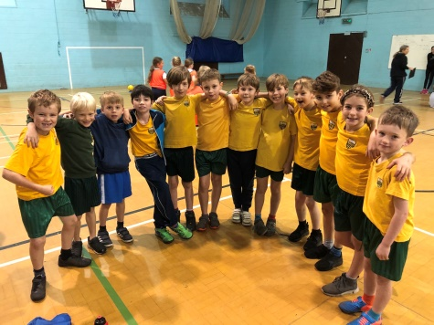

**Sports taught in PE**

Football

Hockey

Athletics

Rounders

Cricket

Dodgeball

Bench ball

Gymnastics

Yoga

Swimming

Multi-skills

**Clubs**

Football

Rugby

Rounders

Netball

Dance

Scatterball

Kwik Cricket

Multigames

Yoga

**Teams represented at events**

Boys Football

Rounders

Indoor Athletics

Cross Country

Dance

Dodgeball

Bench ball

Panathlon

Class 5 took part in the Yorkshire Dance Festival, which was a huge success. (November 2019)

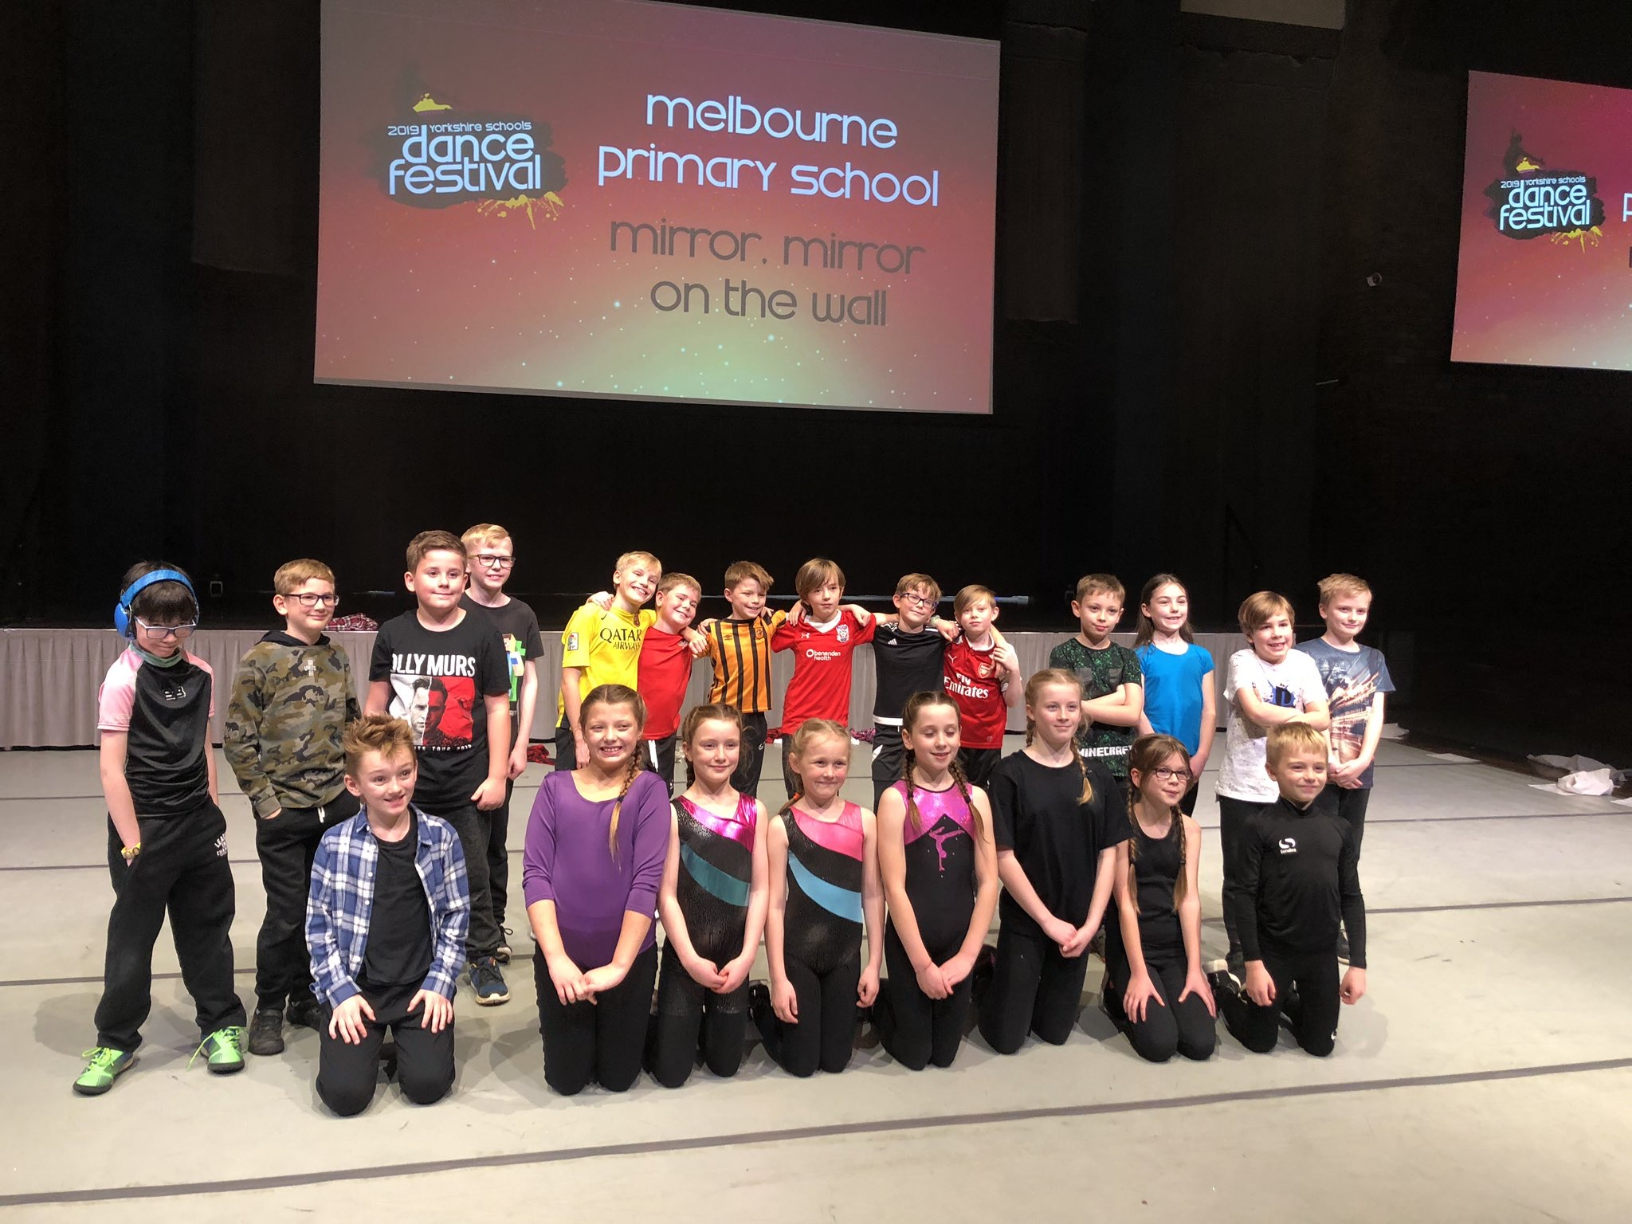

**Physical Education – Healthy habits for life.**

**What PE looks like at Melbourne Primary School?**

PE is taught twice a week for 1 hour each lesson. One lesson is taught by our PE specialist (Miss Welch) and the other session is taught by the class teacher.

Across the school children take part in a wide variety of sports over the school year. Children enjoy these lessons and will hopefully continue to enjoy PE and sport throughout their lives. We have had external organisations come in and deliver session to the children. We ensure feedback is gathered from the children.

Children also have access to a range of after school or lunchtime clubs with some leading to representing school in a sports team. We had some great success with many of our teams and individuals last year. These achievements and any participation is praised during whole school awards assembly.

Across school you will see evidence of how our sports premium has been spent to allow children to have access to quality equipment, exercise and play opportunities and quality PE lessons. You will see active children enjoying PE, competition and other activities. We also encourage children to be active during playtimes. We provide the children with a balls only area and on a Friday, we provide the children with extra equipment during their playtime.

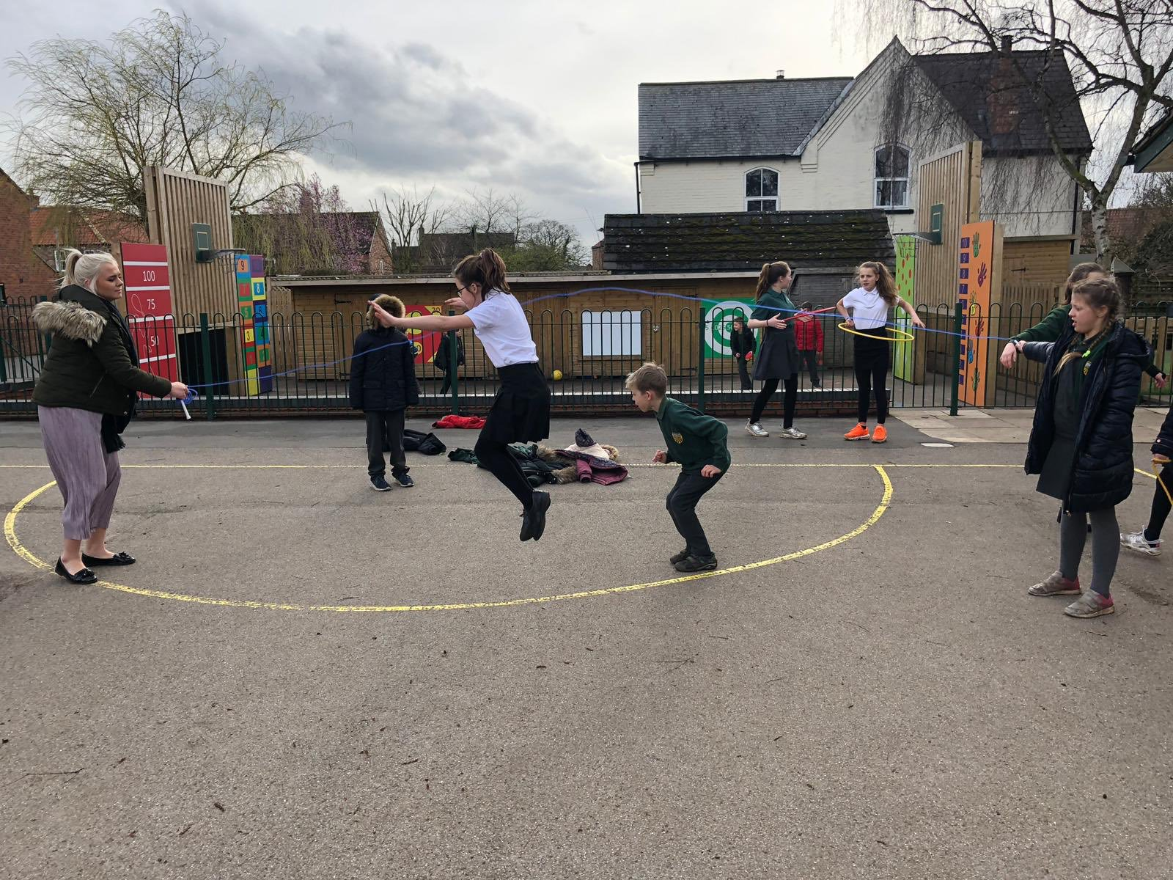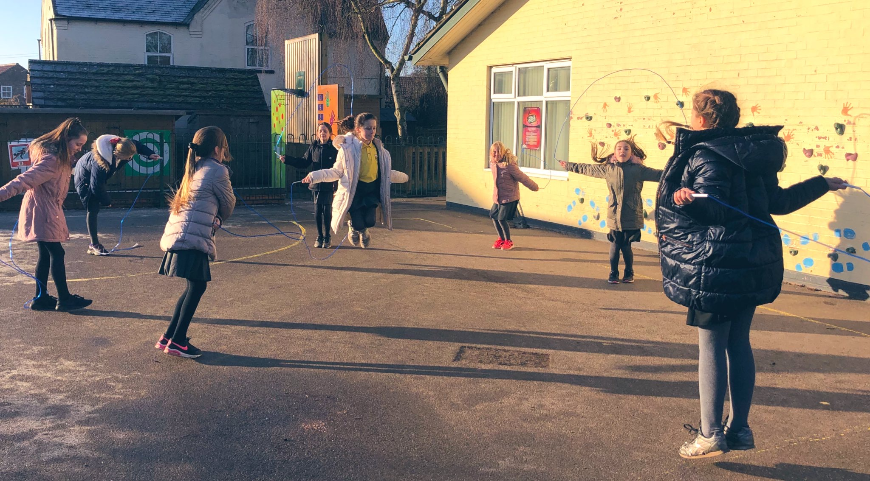

**SEND:**

Children with needs are given opportunities in lessons to work on these skills as well as join in with the usual PE lessons In order to develop team skills and experience competition. We provide these children to opportunity to enhance their leadership skills too within lessons. An event was organised for SEND pupils to attend a full inclusive sporting day. It was a pleasure to see these children flourish. The group of children who attended actually came second in the event.

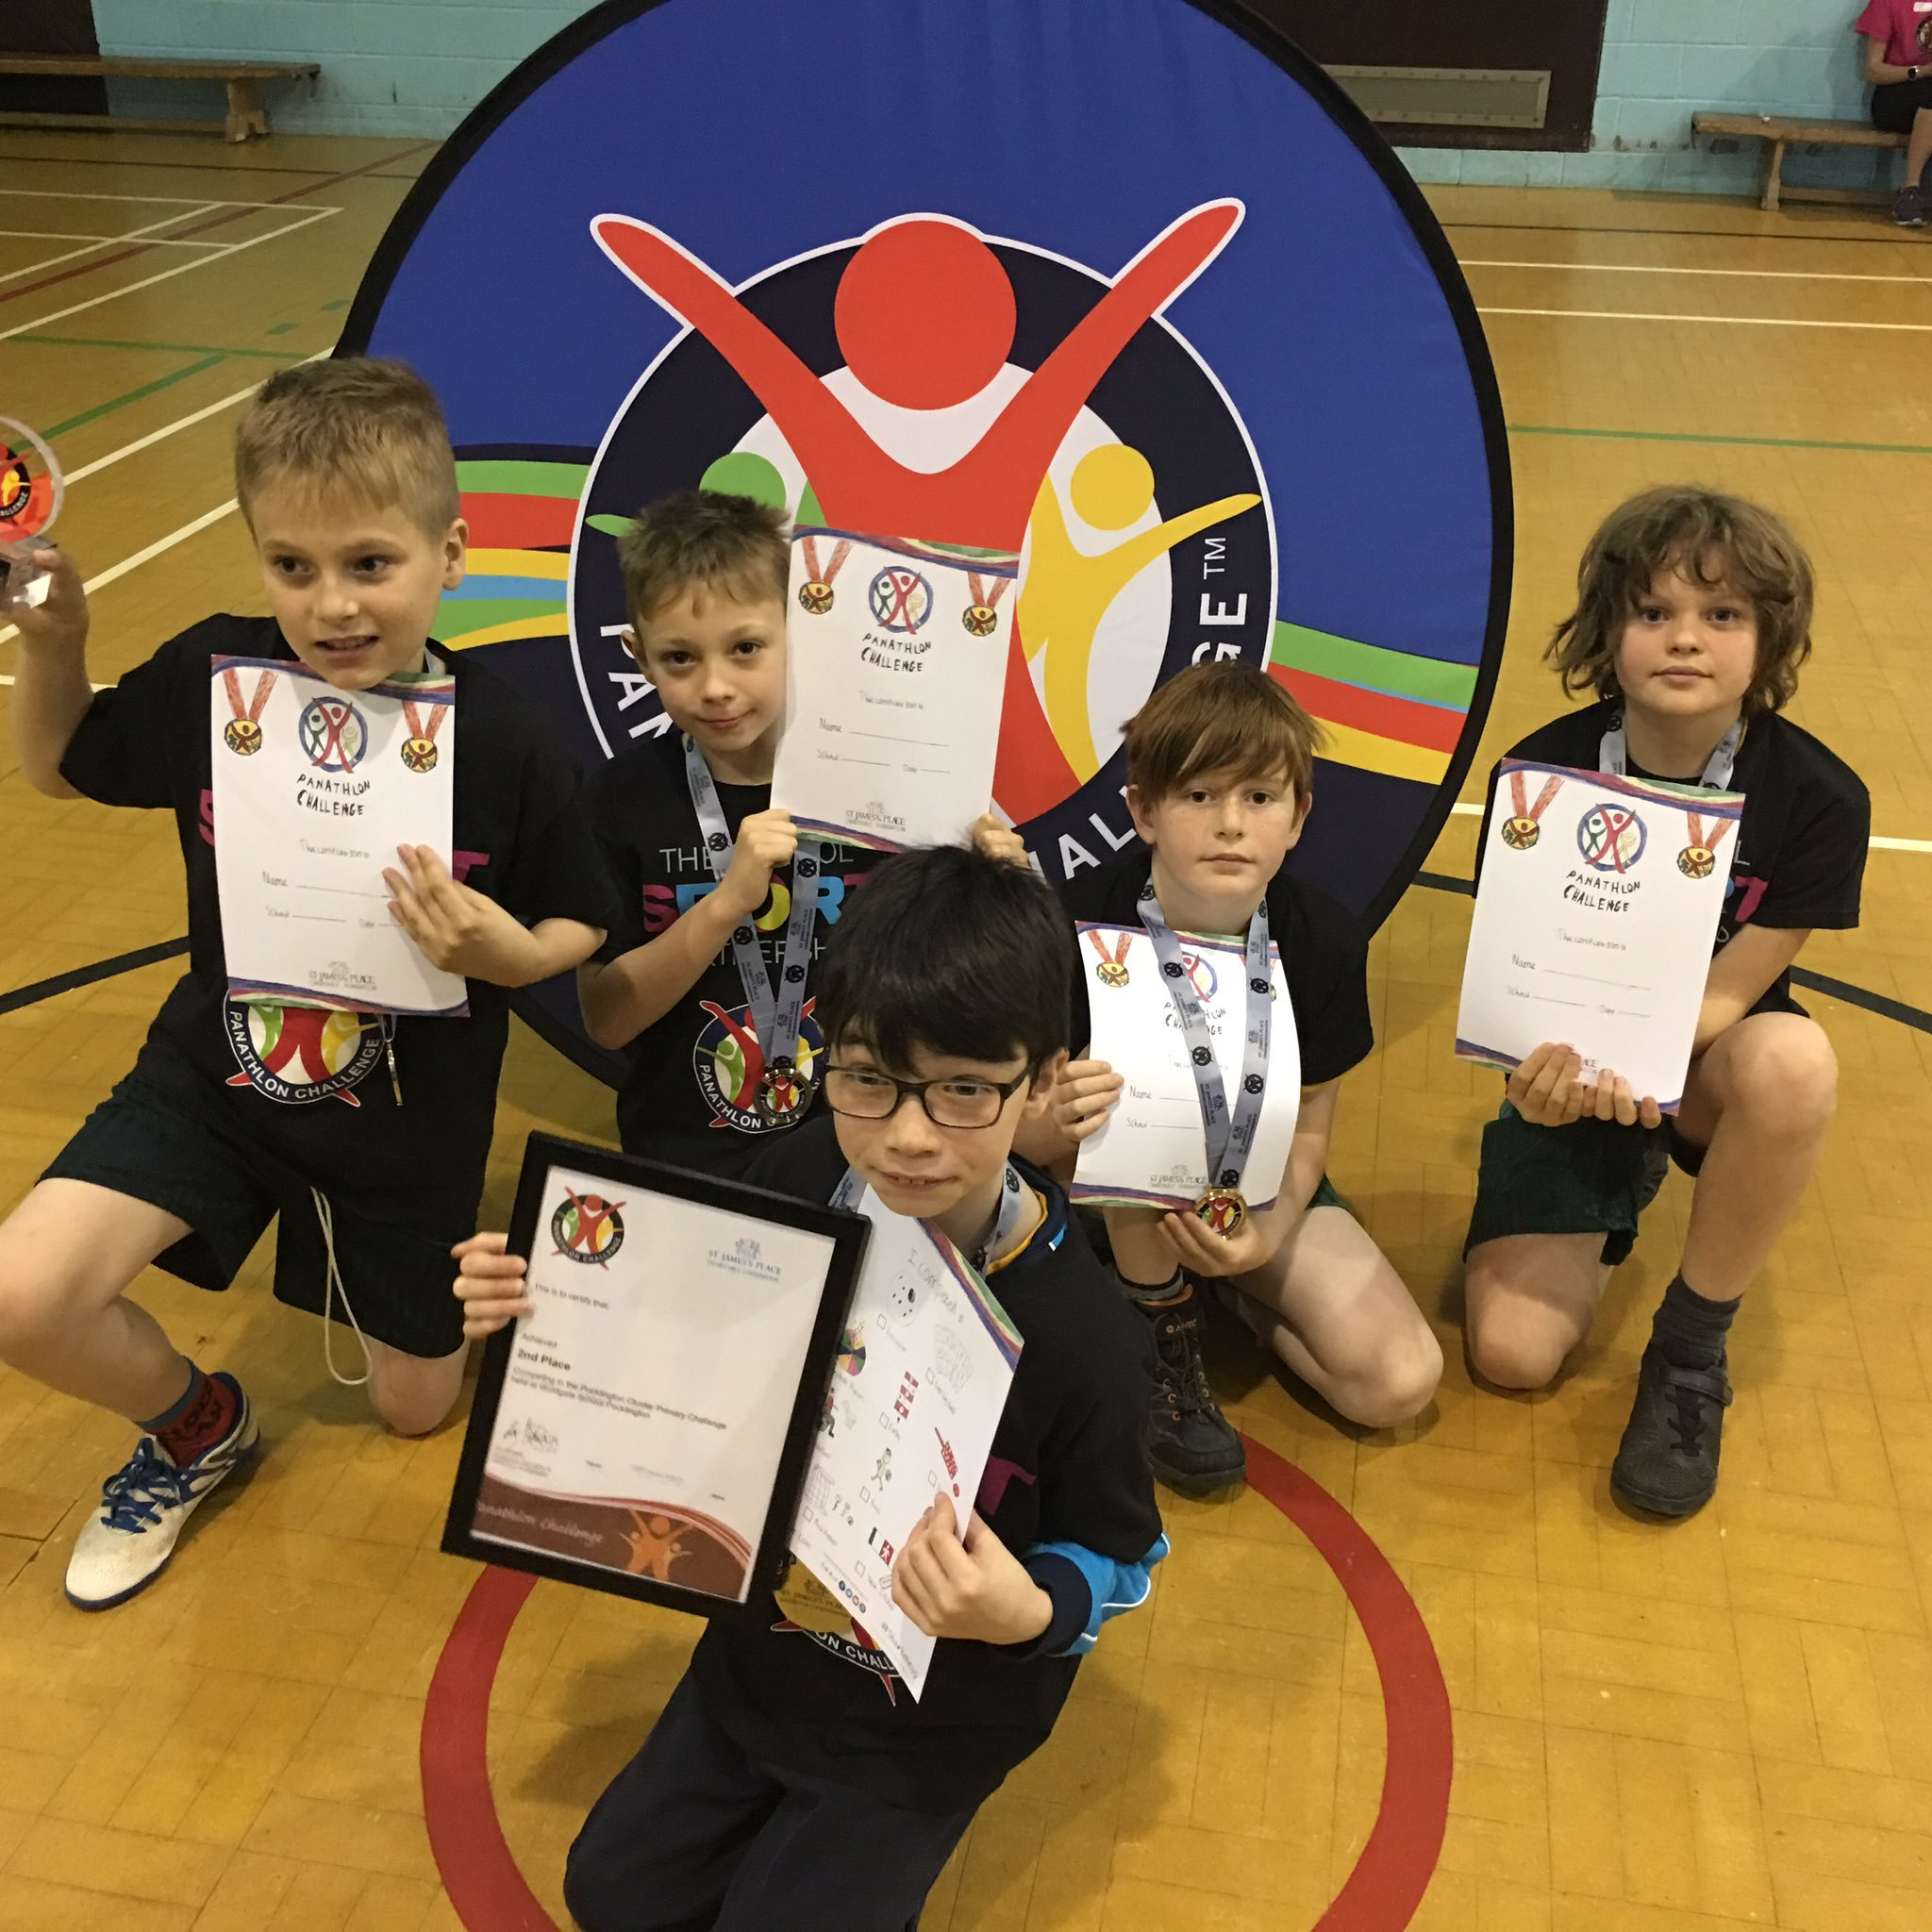

**Key strengths:**

We use pupil voice when selecting sports for each half term as well as looking at the sports we are yet to cover on the curriculum cycle. Our PE ambassadors create a survey to allow all children have their say in the clubs we provide.

Children’s feedback is taken into account and we design the curriculum and medium-term planning to match the needs of all pupils. This includes external organisations who deliver sessions.

We have a high percentage of pupils meeting expected standard in PE

across the school. On track in PE: KS1 (88%) and KS2 (90%).