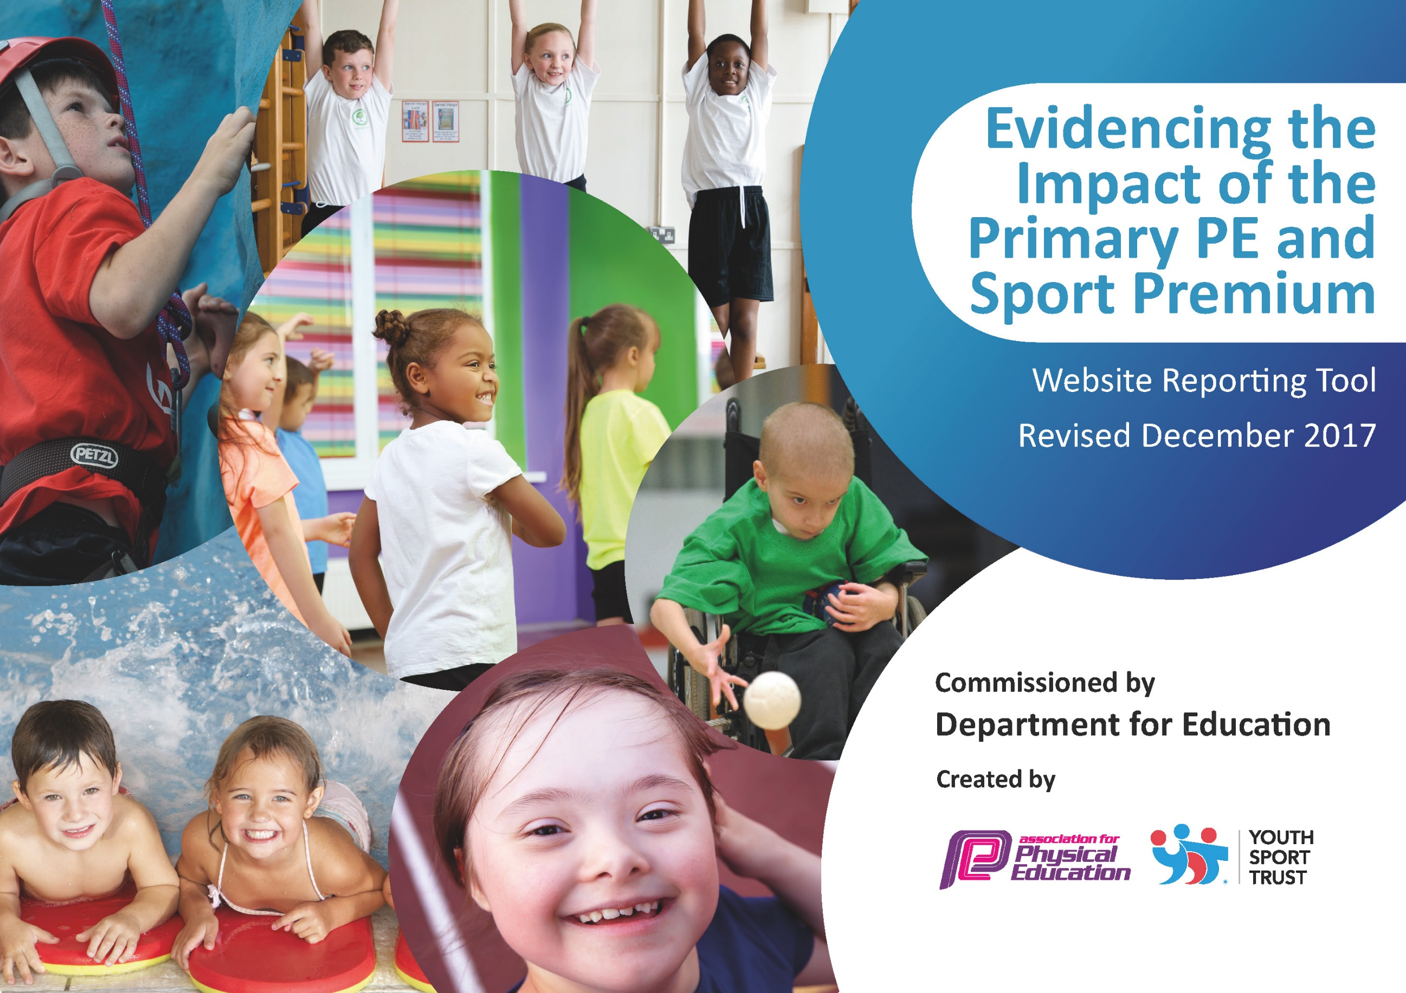

Schools must use the funding to make additional and sustainable improvements to the quality of PE and sport they offer. This means that you should use the Primary PE and Sport Premium to:

- develop or add to the PE and sport activities that your school already offers
- build capacity and capability within the school to ensure that improvements made now will benefit pupils joining the school in future years

Please visit gov.uk for the revised DfE guidance including the 5 key indicators across which schools should demonstrate an improvement. This document will help you to review your provision and to report your spend. DfE encourages schools to use this template as an effective way of meeting the reporting requirements of the Primary PE and Sport Premium.

We recommend you start by reflecting on the impact of current provision and reviewing the previous spend.
Under the Ofsted Schools Inspection Framework, inspectors will assess how effectively leaders use
the Primary PE and Sport Premium and measure its impact on outcomes for pupils, and how effectively governors hold them to account
for this.

Schools are required to publish details of how they spend this funding as well as on the impact it has on pupils’ PE
and sport participation and attainment.
We recommend regularly updating the table and
publishing it on your website as evidence
of your ongoing review into how you are using the money
to secure maximum, sustainable impact. To see an example of how to complete the table please click HERE.

Support for review and reflection - considering the 5 key indicators from DfE, what development needs are a priority for your setting and your students now and why? Use the space below to reflect on previous spend, identify current need and priorities for the future.

Key achievements to date: | Areas for further improvement and baseline evidence of need:
Achieved School Games Award – Achieved Gold Award demonstrating our increasing/ high levels of participation in school games, competitive sports, after school clubs and our commitment to broadening the range of opportunities available to all pupils.  Sporting events and activities celebrated around school including the use of Twitter and the school website and during awards assemblies.  Continuing the PE journal for public display.  Have cemented links with wider community, Academy schools/ Pocklington Prep School/ Dance Festival  Staff CPD focusing on active lessons throughout the curriculum  Appointed Y6 PE ambassadors who lead active playtime and act as a pupil voice for extracurricular clubs. | Maintain Gold standard for required amount of time to get Platinum standard.  Increase opportunities for pupils to ‘set personal targets.’  Continue to develop the PE journal.  Continue developing opportunities for Staff CPD.  Allow children more time to set personal target.

Meeting national curriculum requirements for swimming and water safety | Please complete all of the below*:
What percentage of your current Year 6 cohort swim competently, confidently and proficiently over a distance of at least 25 metres? | 97%
What percentage of your current Year 6 cohort use a range of strokes effectively [for example, front crawl, backstroke and breaststroke]? | 86%
What percentage of your current Year 6 cohort perform safe self-rescue in different water-based situations? | 61%
Schools can choose to use the Primary PE and Sport Premium to provide additional provision for swimming but this must be for activity over and above the national curriculum requirements. Have you used it in this way? | Yes
*Schools may wish to provide this information in April, just before the publication deadline.

Action Plan and Budget Tracking
Capture your intended annual spend against the 5 key indicators. Clarify the success criteria and evidence of impact that you intend to measure to evaluate for students today and for the future.

Academic Year: 2019/20 | Total fund allocated: £17270 | Date Updated: 1/11/12019
Key indicator 1: The engagement of all pupils in regular physical activity – Chief Medical Officer guidelines recommend that primary school children undertake at least 30 minutes of physical activity a day in school |  |  |  | Percentage of total allocation:
School focus with clarity on intended impact on pupils: | Actions to achieve: | Funding allocated: | Evidence and impact: | Sustainability and suggested next steps:
To embed physical activity through having an active playground- sports equipment/climbing wall/ playing field.  Continue to make PE/ play more meaningful and competitive. | Continue to make playground safe and accessible for playing field/ PE lessons, extra-curricular clubs, to host events and for active playtimes.  Storage units for accessible equipment during PE and playtimes.  Play/ PE equipment replenished- soft rugby balls/ netballs/ footballs/ football net/ basketballs/ dodgeballs.  Sports day- running track/netball court.  Bikeability and Pedestrian Training offered to Y4 and Y5/^ pupils to encourage more pupils to safely walk to school or bike | £500  £500  £750  £1000  £420 | Hosting Pocklington football league.  Expansion of extra-curricular clubs and providing our own PE curriculum in house.  Netball markings  Maintenance of the school field for the safety of children for competitions.  Increased percentage of local children not using cars to come to school | Further expansion of competitive sport at ‘home’ and variety of extra-curricular clubs.  ‘In-house’ PE curriculum planned for 2019- 2020.
Key indicator 2: The profile of PE and sport being raised across the school as a tool for whole school improvement |  |  |  | Percentage of total allocation:
School focus with clarity on intended impact on pupils: | Actions to achieve: | Funding allocated: | Evidence and impact: | Sustainability and suggested next steps:
Continue to embed the school values - Care Imagine Believe Strive Achieve -  through PE and sport  Make sport more competitive. | Reward sporting achievements. Purchase awards.  Purchase of sports kit.  Join East Riding Netball League  Join Pocklington Football League  Floodlighting during winter month. | £130  £15  £15  £50 | Interschool netball/football matches.  Awards assemblies and recognition  Internal notice boards  Newsletter and press  Sports journal  Yr 5 & 6 ambassadors for sport.  Introduce the golden ticket

Key indicator 3: Increased confidence, knowledge and skills of all staff in teaching PE and sport |  |  |  | Percentage of total allocation:
School focus with clarity on intended  impact on pupils: | Actions to achieve: | Funding  allocated: | Evidence and impact: | Sustainability and suggested  next steps:
Professional development of subject leader, teachers and TA’s.  CPD booked for Spring Term 2019. | All teaching staff CPD focus on outdoor games and Problem solving skills.  2x teachers receive modelled PE lesson and all staff take twilight CPD session.  Providing staff with continuous professional development and supporting the creation, preparation and delivery of high quality, structured PE in line with the new national curriculum expectations.  Half day CPD booked with Partnership Lead to deliver active Maths & active English session with all staff.  PE Coordinator quality assures work of sports coach and other teachers by observing lessons and outcomes. | £1500  £500  £950 | All teachers to provide confident delivery of high quality PE in KS1 & KS2 and develop enhanced sports specific skills leading to outstanding (teacher led) lessons in PE across the school.  All sports lessons to be of a high quality and provide opportunities for all pupils
Key indicator 4: Broader experience of a range of sports and activities offered to all pupils |  |  |  | Percentage of total allocation:
School focus with clarity on intended  impact on pupils: | Actions to achieve: | Funding  allocated: | Evidence and impact: | Sustainability and suggested  next steps:
Additional achievements:  Introduce new sports and run and extend after school clubs and activities to encourage all encourage all pupils to take up sport and physical activity. | Participation in the Yorkshire Schools Dance Festival- Nov 19  Participation in outdoor activities through an organised outdoor pursuits centre – transport and staff support.  Variety of lunchtime/after school clubs being run 5 days a week. Sports clubs to change each term  Taekwondo taster sessions booked in on a regular basis for all pupils | £820  £1500  £2325  £200 | All participants receive a certificate – increased participation from last year.  All Y6 children encouraged to attend  Percentage of attendance at extra-curricular club has increased dramatically from 27% to 65%.  Increased uptake at local taekwondo sessions
Key indicator 5: Increased participation in competitive sport |  |  |  | Percentage of total allocation:
School focus with clarity on intended  impact on pupils: | Actions to achieve: | Funding  allocated: | Evidence and impact: | Sustainability and suggested  next steps:
Wider range of competitive sports opportunities for pupils. | Contribute to the local School Sports Partnership / East Riding SSP competition calendar in order to access good quality inter competition.  Transport to swimming lessons  Certificates for swimming awards.  Staff support to ensure that pupils have the opportunity to attend competitions.  Transport for pupils to events to ensure that all can attend.  Allerthorpe trip – visit to local centre for outdoor activity – including open water swimming opportunities  Affiliation to local trampolining club to allow pupils to compete under the schools name | £1,750  £1,500  £75  £1500  £750  £500  £20 | Expand the opportunities open to all pupils in KS1 and KS2.  Cross Country/ Athletics  Football - Woldgate, Pocklington Prep School x 2, Pocklington League.  Dodgeball  Swimming  Benchball  Netball league  KS1 3 in a bucket  Y5/6 Tag Rugby  Rounders  Providing all of Y1 and 2 the opportunity to experience a range of competitive sports.  Heslington Floodlighting  Achieved Gold  Opportunity for all Y4/5 children to attend a local and easily accessible outdoor sports centre  Highlighting trampolining opportunities to all pupils

