Pupil premium strategy statement
- Summary information
School | MelbourneCommunity Primary School
Academic Year | 2019-20 | Total PP budget | £13840 (plus the LAC funding that can be applied for termly – a maximum of £2300 per child per year) | Date of most recent PP Review | N/A
Total number of pupils | 170 | Number of pupils eligible for PP | 9 | Date for next internal review of this strategy

Previous performance of pupils eligible for Pupil Premium – 2018-19
EYFS 2018-19 (22 pupils) | EYFS
Proportion of pupils achieving a good level of development (GLD) | PP: 0  Non PP:72.7% (22 pupils)
Proportion of pupils achieving at least the expected standard in Reading | PP: 0  Non PP: 76.9% (22 pupils)
Proportion of pupils achieving at least the expected standard in Writing | PP: 0  Non PP: 73.8 (22 pupils)
Proportion of pupils achieving at least the expected standard in Number | PP: 0  Non PP: 79.7% (22 pupils)
Year 1 2018-19 Phonics ( 26 pupils) | Phonics screening
Proportion achieving at least the expected standard in Year 1 phonics | PP: 12% (3 pupils) 8% achieved  Non PP:88%(23 pupils) 96.2% achieved
Key stage 1 2018-19 (26 pupils) | Key Stage 1
Proportion of pupils achieving at least the expected standard in Reading | PP: 8% (2 pupils) 0% achieved  Non PP: 92% (24 pupils) 62.2% achieved
Proportion of pupils achieving at least the expected standard in Writing | PP: 8% (2 pupils) 0% achieved  Non PP: 94% (24 pupils) 65.4% achieved
Proportion of pupils achieving at least the expected standard in Maths | PP: 8% (2 pupils) 0% achieved  Non PP: 94% (24 pupils) 69.2% achieved
Key Stage 2 2018-19 (27 pupils) | Key Stage 2
Proportion of pupils achieving at least the expected standard in Reading | PP: 3% (1 pupils) 0% achieved  Non PP: 97% (27 pupils) 70% achieved
Proportion of pupils achieving at least the expected standard in Writing | PP: 3% (1 pupils) 0% achieved  Non PP: 97% (27 pupils) 74% achieved
Proportion of pupils achieving at least the expected standard in Maths | PP: 3% (1 pupils) 100% achieved  Non PP: 97% (27 pupils) 74% achieved
Proportion achieving at least the expected standard in RWM combined | PP: 3% (1 pupils) 0% achieved  Non PP: 97% (27 pupils) 63% achieved

Tackling Barriers
Melbourne Primary School works on the principle that consistently great teaching is the best way to overcome the barriers to learning our pupils face. Our school is beginning to explore a range of strategies that are underpinned by a strong evidence base:
• Frequent, evidence based CPD focused on the needs of the pupils, particularly those from disadvantaged backgrounds.
• Ensuring disadvantaged pupils access very high early years provision
• The development of a language-rich curriculum
• Cultural enrichment opportunities, e.g. making the most of our locality, residential trips to Kingswood, religious visitors and trips, regular outdoor learning opportunities, visits to a range of places linked to our current themes and sporting opportunities
• The school actively engages with parents through Early Years stay and play sessions, celebration assemblies, parental helpers in school and offering information sharing events.

EYFS

There were not any children in receipt of PP last year.

Key Stage 1
There were 2 PP children within the Y2 cohort last year. Both children are also on the SEND cause for concern list. Despite strong teaching and appropriate intervention these children were not able to meet age related expectations by the end of the year. However, evidence (book scrutiny etc.) suggests they made visible progress across the core subjects.

Key Stage 2
The graph demonstrates progress measures for the Y6 PP and non PP children’s progress. The data provided demonstrates that progress in reading was poorer than non PP children but progress in maths and writing was better than non PP children.

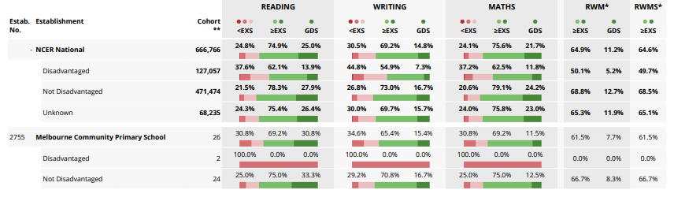
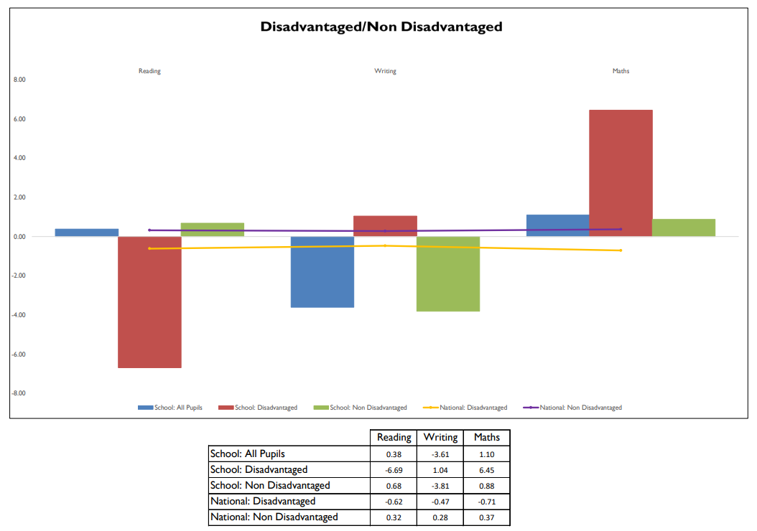

- Barriers to future attainment (for pupils eligible for PP, including high ability)
In-school barriers which some of our eligible pupils face:
 |  | Language deficit (speech and language barriers) - both a gap in vocabulary and a lack of ability to manipulate language for effect
 |  | Social, emotional and behavioural problems impact well-being and progress. Some children have support from external agencies due to a range of complex needs
C. |  | Limited cultural capital and enrichment which limits language and understanding
D. |  | Special educational needs in relation to reading comprehension, maths and writing (dyslexic tendencies – these existing barriers to learning impact further on rates of progress and therefore attainment.
E. |  | Lack of metacognitive strategies
External barriers (issues which also require action outside school, such as low attendance rates)
F. |  | Pupil attendance, although generally good is weaker for PP eligible pupils compared to non Pupil Premium children.
G. |  | Home environment and/or lack of routine means that PP children arrive less prepared or resourced for learning e.g. incomplete home learning, missing uniform, disrupted evening/ morning routine, emotional difficulties.
- Desired outcomes
1 | Progress of all learners will be at least expected or better than expected in reading, writing and maths.
2 | Children eligible for PP funding, who have identified gaps in learning, will make rapid progress compared with their non-eligible peers. (at least 0.0)
3 | Attendance rates for PP children will improve and align with the whole school target of 98%.
4 | 90+% of PP children will be at age-related expectations when assessed against the learner characteristics at the end of the academic year.
5 | To further develop effective leadership and management strategies to build a sustainable approach to reviewing and monitoring interventions.

- Planned expenditure
Academic year | 2019-2020
Desired outcomes
1. Progress of all learners will be at least expected or better in core subjects.
2. Attendance rates for PP children will improve and align with the whole school target.
3. PP children will be have the skills to manage their emotions and be happy during school.
Desired outcome | Chosen action / approach including cost | What is the evidence and rationale for this choice? | How will you ensure it is implemented well? | Staff lead | When will you review implementation?
Improved outcomes in writing and maths as a result of timely intervention. | Target teaching support by accurately assessing pupil needs and providing increased opportunities for providing pupils with same day intervention, including pre teaching.  £2696.40  Use of TT Rockstars to develop children mathematical progress.  £201.75  External advisory services (maths and English).  £2400 | Links to the whole school priority for mathematic and writing.  Evidence: EEF identified approaches  Individualised instruction: +3 months  The Sutton Trust’s report states: “The effects of high-quality teaching are especially significant for pupils from disadvantaged backgrounds: over a school year, these pupils gain 1.5 years’ worth of learning with very effective teachers, compared with 0.5 years with poorly performing teachers.  ‘High quality teaching therefore disproportionately benefits disadvantaged children…if you teach well and they learn well, the gap should narrow.’ John Dunford, National Pupil Premium Champion. | The progress of eligible pupils will be in line with non-eligible pupils.  The percentage of disadvantaged and non-disadvantaged pupils reaching the expected standard in writing and maths will increase at the end of Key Stage 2 in 2019/20.  We will monitor teaching and learning, scrutinise planning and books and talk to pupils about the impact intervention is having on their progress and self-belief. | JB/CF/KF/CFi | Data collection points:  2019  December 2019  February 2020  April 2020  June 2020
We will monitor the teaching of spelling groups in all year groups. Through exploring retention and application during writing tasks.

We will track pupil writing progress.

We will track Lexia personalised learning paths/progress made.

Increased atomicity and fluency when spelling. | Target phonics teaching /spelling lessons.  Use of Lexia for specific targeted children.  £1540  Personalised spelling lists are provided for children which included HFW and CEW – these basic skills are secured before moving on. | Individualised instruction involves different tasks for each learner and support at the individual level. It is based on the idea that all learners have different needs, and that therefore an approach that is personally tailored — particularly in terms of the activities that pupils undertake and the pace at which they progress through the curriculum — will be more effective. Teaching Learning Toolkit EEF 2019  Evidence: EEF identified approaches  Individualised instruction: +3 months | We will monitor the teaching of spelling groups in all year groups. Through exploring retention and application during writing tasks.  We will track pupil writing progress.  We will track Lexia personalised learning paths/progress made. | JB/KF/CF | Data collection points:  2019  December 2019  February 2020  April 2020  June 2020
Improved understanding and application of vocabulary in relation to maths and writing. | Provide children with individual topic specific prompt sheets that include relevant vocabulary.  The use of working walls to display relevant and topic specific vocabulary.  Class 5 will take part in the Write Time Project which is designed to improve the quality of writing including use of vocabulary.  £3800 | Links to the whole school priority for mathematic and writing action plan. Research suggests that if children’s vocabulary is developed progress is maximised. | Monitor teaching and learning,  display, pupil voice and scrutinising planning and pupils books. | JB/KF/CF
To offer Emotional Literacy Support Assistant (ELSA) support for vulnerable children. | Children will develop strategies to support their emotional wellbeing. Children will apply these strategies to support them in class.  £3196.40 | Rationale: Developing pupil’s emotional resilience enables them to access learning when back in class. Evidence: EEF social emotional learning Feedback: +4 months | Monitor CPOMs for behaviour and attitudes. Discussions with staff. | JB/KF/CF | Half termly
To offer vulnerable children targeted maths intervention which addresses gaps in learning. | Identify and develop an intervention approach for each year group which addresses basic maths skills. Use the ‘Hands on’ maths materials to do this.  Training will be supplied to those members of staff who plan to deliver this.  £2596.40 | Individualised instruction involves different tasks for each learner and support at the individual level. It is based on the idea that all learners have different needs, and that therefore an approach that is personally tailored — particularly in terms of the activities that pupils undertake and the pace at which they progress through the curriculum — will be more effective. Teaching Learning Toolkit EEF 2019  Evidence: EEF identified approaches  Individualised instruction: +3 months | The maths lead will devise an intervention scheme using the ‘Hands on’ approach to ensure that children’s mathematic conceptual understanding is developed.  Once the intervention scheme is developed appropriate staff training will be delivered to ensure that the intervention is delivered effectively.  Each class teacher will highlight and track children who require this intervention. | CFo/CF/KF | Intervention devised – October 2019  Training given – Nov 2019  Effectiveness evaluated – every half term once the intervention has started
TOTAL COST: £14334.55 (PLUS additional cost built in to teacher and teaching assistant salaries)

- Review of expenditure 2019/20
Desired outcome | Chosen action/approach | Estimated impact: Did you meet the success criteria? Include impact on pupils not eligible for PP, if appropriate. | Lessons learned  (and whether you will continue with this approach) | Cost
Improved outcomes in writing and maths as a result of timely intervention. | Target teaching support by accurately assessing pupil needs and providing increased opportunities for providing pupils with same day intervention, including pre teaching.  Use of TT Rockstars to develop children mathematical progress.  External advisory services (maths and English). | Due to the Coronavirus 19 pandemic the statutory assessments did not take place. Therefore, there is no available progress data. Alongside this there was significant disruption to learning over the course of the year due to school closures.  Monitoring in writing and maths that took place up until March 2020 demonstrated progress over time being made.  Same day intervention has proven valuable in providing follow up support or preteaching activities.  In terms of writing children engaged well with the revised approach to writing and responded positively to the emphasis placed on teacher modelling. Unfortunately, school closure led to the inability to embed practice. | Revise the approach to teaching writing as a process in light of the external advisory service received and the project completed.  Continue to use ‘same day intervention’ for PP children who require this additional support. | £5298.15
Increased atomicity and fluency when spelling. | Target phonics teaching /spelling lessons.  Use of Lexia for specific targeted children.  Personalised spelling lists are provided for children which included HFW and CEW – these basic skills are secured before moving on. | The data pulled from Lexia demonstrates all PP children made progress through the programme levels. This resource also proved valuable during school closure due to children being able to access at home.  Personalised spelling lists works well and ensured firm foundations were achieved prior to progressing to next steps.  Up until school closure children were receiving targeted phonics teaching in appropriately challenging phonic groups. | Continue to use Lexia to support those PP children who require support with phonics/spelling. Invest time in exploring the ‘supplementary’ resources that are generated to support further intervention/support.  When the Coronavirus restrictions allow we will continue to implement targets phonics/spelling groups. | £1540
Improved understanding and application of vocabulary in relation to maths and writing. | Provide children with individual topic specific prompt sheets that include relevant vocabulary.  The use of working walls to display relevant and topic specific vocabulary.  Class 5 will take part in the Write Time Project which is designed to improve the quality of writing including use of vocabulary. | This is an area that will need to continue to feature in the strategy next year.  Working wall present in all classrooms and children use if directed to do so. This isn’t as automatic as hoped and requires a period of embedding.  In terms of writing children engaged well with the revised approach to writing and responded positively to the emphasis placed on teacher modelling and direct teaching of phonics. Unfortunately, school closure led to the inability to embed practice. | Not as much progress made in this area as liked. More time needed to review current practice and implement change as necessary and embed current good practice. | £3800
To offer Emotional Literacy Support Assistant (ELSA) support for vulnerable children. | Children will develop strategies to support their emotional wellbeing. Children will apply these strategies to support them in class. | Children with emotional difficulties to be identified and relevant blocks of work taught. Children monitored closely following the conclusion of a programme to ensure strategies are fully applied in less structured environments. Where this isn’t the case further support should be put in place immediately. | Continue to use this essential strategy for those children requiring additional emotional support – particularly those who found school closure challenging. | £3196.40
To offer vulnerable children targeted maths intervention which addresses gaps in learning. | Identify and develop an intervention approach for each year group which addresses basic maths skills. Use the ‘Hands on’ maths materials to do this.  Training will be supplied to those members of staff who plan to deliver this. | Teaching staff identified children who had gaps in their mathematical conceptual knowledge. Children received regular intervention to address gaps and maximise progress. | Continue to utilise this strategy for those children who require support to develop conceptual mathematics. | £2596.40

